Software Quality Assurance Test Plan
Date:
Version:
Status:
Author:
Reviewed by:
Approved by:

Revision History
Date | Version | Description | Author

Table of Contents
1 Introduction 5
1.1 Purpose 5
1.2 Background 5
1.3 Scope 5
1.4 Assumptions 6
1.5 Risks and contingencies 7
1.6 Constraints 8
1.7 Project Artifacts 9
2 Work Products under Test 10
2.1 XXXXXXX Supported Versions 10
2.2 Test Matrix 11
2.2.1 Topology 11
2.2.2 Roles and Configurations 13
3 Test Requirements 15
New features shall be tested 15
Faults Fixed 15
4 Test Strategy 16
4.1 Test Script Execution 16
4.2 Regression Testing 16
4.3 Testing Types 16
4.4 Testing Criteria 17
4.4.1 Test Readiness Criteria 17
4.4.2 Test Stop Criteria 17
4.4.3 Test Success Criteria 17
4.4.4 Regression Test Criteria 17
4.4.5 Engineering Documentation System Criteria 18
4.5 Tools 18
5 Resources 18
5.1 Staffing 18
5.2 Hardware/Devices & Software 19
5.2.1 Hardware and Devices 19
5.2.2 Software 20
5.2.3 Machine Setup Model 20
6 Communications Channels 20
7 Estimation 21
8 Deliverables 22
8.1 Test Artifacts 22
8.2 Test Logs 22
8.3 Defect Reports 23

Test Plan

Introduction

Purpose
This test plan supports the following objectives:
- Identify existing project information and the software components that should be tested
- List the recommended test requirements (high level)
- Recommend and describe the testing strategies to be employed
- Identify the required resources and provide an estimate of the test efforts
- List the deliverable elements of the test project

Background
VMware is an operating system that provides for the definition of multiple virtual server operating environments, each running a different O/S potentially, using a single physical server. VMware is growing in popularity due to the ROI incurred from power and cooling savings along with intangibles such as reduced administration costs from consolidating multiple physical machines onto a single machine that is partitioned. Many XXXXXXX partners are shipping hardware with a VMware option and field sales is reporting an increase in the number of prospects looking for VMware support by their BAR vendor.
Summary benefits of VMware Server:
- Provision a new server in minutes without investing in new hardware.
- Run Windows and Linux operating systems and applications on the same physical server.
- Increase the utilization of a physical server.
- Move virtual machines from one physical host to another without re-configuration.

It is the intention of this document to outline the requirements for testing and validation of the XXXXXXX 7.1.2, and 7.4.2 product s within this operating environment (VMWare ESX 3.0) in order to deem the solution as supported by the Research and Development organization within the scope of requirements set forth by the ‘XXXXXXX Software Project Scoping Document - XXXXXXX and VMWare Support’ artifact. This Plan does NOT cover testing of the range of guess operating system support environments nor the Applications support in guest operating system environments. The intention of this testing will be to validate the backup and restoration on console and virtual disks on an ESX server version 3.0.

Scope
The testing is limited to specific tests to cover the functionality addressed by the test suites outlined in table 1.

Table 1.Target Test Suites
Test Suite Name | Version
Test Suite.doc | 1.1

For specific functionality being tested against the proposed environments and configurations please refer to the respective test suites mentioned above at DMS.

Assumptions
- All test binaries shall be downloaded from the Binary Management System
- Detailed testscript(s) shall be downloaded from the Document Management System unless otherwise specified
- If necessary and for XXXXXXX own benefits, XXXXXXX may translate or convert the existing test script(s) to XXXXXXX own latest format test script(s) but there won’t be any resource time allocate for this task.
- XXXXXXX may need to ‘specify’ reduced port test sections from the current test script.
- The testscript should be updated with testcases for all fault fixed/new features including in BMSes under test.
- The modular architecture of the XXXXXXX product limits the scope of faults to impact on modules other than the module where the fault occurs.
- This test plan is created based on high-level requirements from BKB emails/meetings. Detailed information should be added during test phases if needed.
- Test artifacts are either resident on the BMS or attached to their relevant FMS/Jira.
- All test documentation is resident on the DMS or official VMware websites.
- XXXXXXX has all necessary equipments and knowledge to setup environment.
- If XXXXXXX is unable to use or is unable to implement the testing with the hardware/test cells in offshore, then XXXXXXX would need onshore to setup the testing environment. Then new setup/prepare schedule would need to allocate. It is responsibility of XXXXXXX to notify XXXXXXX if this is the case.
- If XXXXXXX is unable to perform both XXXXXXX1.x and XXXXXXX4.x at the same time due to resource problem, it is possible that testing will be serialized. It is responsibility of XXXXXXX to notify XXXXXXX if this is the case.
- Testing Staff are competent in the operating environments outlined in table 2.0 and they also have a degree of understanding of VMWare backup and restore methodologies.
- VMWare ESX 3.0 Server Software and Licensing (can be found at Wiki)
- Technical Contact at VMWare specifically geared towards providing the means for 3rd Party Software Validation. If this is not possible technical contacts that can provide thorough and precise support for technical alliance related issues will require.
- Technical Leads responsible for QA Test Effort issue escalation required.
Table 2.Target Test Guest Operating Systems
X86-32 bits –Target Test Guest Operating Systems
Windows | Linux
Windows 2003 SP1 | RHELV3U4

X86-64 bits –Target Test Guest Operating Systems
Windows | Linux
Windows 2003 SP1 | RHELV3U4

Note: Again this testing does not cover a testing of neither the range of guess operating system support environments nor the Applications support in guess operating system environments

Risks and contingencies
GENERAL:
- No formal meeting within the Development, QA and PM team for scoping the work before starting a project.
- XXXXXXX core software may have (known and unknown) issues that could be impact to the application module.
- There wouldn’t be any new features, or new fault fixes for this release
- Testing being performed by XXXXXXX, lack of experiences of XXXXXXX and VMware may produce lots of clarification and help request. There should be some buffer time, contingency time allocated for the project.
- If XXXXXXX has problems executing the test script, it could affect the delivery schedule.
- XXXXXXX will be using hardware/test cells offshore. Remote access to XXXXXXX Lab machines may be limited and may affect the testing schedule.
- If XXXXXXX unable to use or unable to implement the testing with the hardware/test cells in offshore, then XXXXXXX would need onshore to setup the testing environment. Then new setup/prepare schedule would need to allocate. It is responsibility of XXXXXXX to notify XXXXXXX if this is the case.

VMWare:
A1 – XXXXXXX Client on Service Console Validation:
- Risk1 – XXXXXXX Client software may have issues with ‘/vmfs’ related mount points (Refer to Article ID 1166 within VMWare Knowledge Base).
- Risk2 – XXXXXXX Client software may have issues with installation on Service Console as the Service Console runs a proprietary version of Linux (Refer to Article ID 193 within VMWare Knowledge Base).
- Contingency1 – Development Support may be required if this issue arises and prevents progress with test efforts.
- Contingency2 – Development Support may be required if this issue arises and prevents progress with test efforts.
B1 – XXXXXXX Smart Client on Service Console Validation:
- Risk1 – XXXXXXX Client software may have issues with ‘/vmfs’ related mount points (Refer to Article ID 1166 within VMWare Knowledge Base).
- Risk2 – XXXXXXX Client software may have issues installation as the Service Console runs a proprietary version of Linux (Refer to Article ID 193 within VMWare Knowledge Base).
- Risk3 – Since the Service Console runs a proprietary version of Linux our SCSI pass-through driver may not work properly.
- Contingency1 – Development Support may be required if this issue arises and prevents progress with test efforts.
- Contingency2 – Development Support may be required if this issue arises and prevents progress with test efforts.
- Contingency3 – Development Support may be required if this issue arises and prevents progress with test efforts.
C1 – Guest Operating System Virtual Disk File Backup Investigation:
- Risk1 – Not all Linux commands and third-party backup software such as XXXXXXX can access VMFS directly. Also, this method places a heavy load on the service console, since it has to run the backup agent software and has to pass all the virtual machine data to tape. As the virtual disk file grows so does the burden on the system and the network.
- Risk 2 – This may require integration and test efforts that may yield unsatisfactory results.
- Risk3 – If the Service Console Crashes due to issues related to Virtual Disk Backup / Restore operations then ALL virtual clients will be inaccessible.
- Contingency1 – Other methods to backup Virtual Disk Files will be explored if possible.
- Contingency2 – Other methods to backup Virtual Disk Files will be explored if possible.
- Contingency3 – Other methods to backup Virtual Disk Files will be explored if possible.

Constraints
A2 – XXXXXXX Client on Service Console Validation:
- Constrain 2.1 – VMFS object files and logs may not be visible or properly accessible to the XXXXXXX Client Software hence not allowing full recovery of Service Console.
- Constrain 2.2 – Service Console runs a proprietary version of Linux some standard XXXXXXX Client Software functions and features may not be available and may require further R&D efforts.
B2 – XXXXXXX Smart Client on Service Console Validation:
- Constraint 4.1 – If Virtual Machine is not available devices and media will also not be available for backup / recovery operations. These Virtual Machines are recommended to be ALWAYS accessible to the XXXXXXX Backup Server. If they are not, interaction with the VMWare product will be required.
- Constraint 4.2 – Dynamic Drive Sharing is currently not supported. Preliminary investigations related to drive locking/unlocking between virtual clients seems to indicate reboots are required. The investigation has been limited by external resources.
C1 – Guest Operating System Virtual Disk File Backup Investigation:
- Constraint 5.1 – We are limited by the access level provided by the XXXXXXX Client Software with relation to the VMFS filesystem. Although there are Pearl API functions that can be leveraged, the exact result of such integration work is not yet known. This may result in unsatisfactory results and may require further R&D efforts.
NOTE 1: There are other tools to export the Virtual Disk Files so that they may be backed up and restored but this is not a area of expertise hence integration efforts may yield substandard solutions. The following are alternatives to indirectly access to the VMFS filesystem:
  - vmkstools (export to NFS mount)
  - SAN Image using 3rd party application

*NOTE 2: It is expected that the XXXXXXX will carry out the test plan. The access to all the necessary test environments and equipment will be made available where possible, particularly libraries and servers to outside members of this test team. Although local access for test purposes is not an issue, and remote access can be made available for coding efforts, limitations by external variables may vary the effectiveness of the test plan execution.

- The completion date of this project may also depend on the number of defects found during testing and feedback rate from XXXXXXX development team.
- Physical tape drives and library may not available in offshore for testing. Offshore shall use virtual drive / library or shall remote use the devices in SD office. Offshore shall notify XXXXXXX about the limitation of testing result, due to the lack of hardware.

Project Artifacts
The table below identifies the documentation and availability pertaining to the project:

Document  (and version / date) | Created or Available | Received or Reviewed | Author or Resource | Notes
Requirements Specification | □ Yes ☑ No | ☑ Yes ☑ No |  | Reduced Version has been provided
Functional Specification | □ Yes ☑ No | □ Yes ☑ No |  | No Functional Spec has been provided for API work
Use Case | □ Yes ☑ No | □ Yes ☑No |  | This methodology has not been implemented at this time
Project Plan | □ Yes ☑ No | □ Yes ☑No |  | No project plan has been provided
Design Specifications | □ Yes ☑ No | □ Yes ☑ No |  | No Design Specification has been provided
Prototype | □ Yes ☑ No | □ Yes ☑ No
Users Manuals | ☑ Yes □ No | ☑ Yes □ No |  | VMWare Documents are available via xxxxxxxx or DMS
Data Model / Flow | □ Yes ☑ No | □ Yes ☑ No |  | No Data Model / Flow Specification have been generated
Project / Business Risk Assessment | □ Yes ☑ No | □ Yes ☑ No |  | No Risk Assessment has been provided

Work Products under Test

XXXXXXX Supported Versions
- XXXXXXX 7.4.2 (BMS ID 8345) would be the primary version for Full test scenario and XXXXXXX 7.1.2 (BMS ID 6566) would be version for Reduced test scenario.

Various binaries will be used to certify specific configurations for use within target VMWare environments. Table 3 outlines those binaries which will be targeted for test and validation.
Table 3.AUT - XXXXXXX Server / Client

X86 Based System – XXXXXXX Server / Client / Related Software
VMWare Server | Guest Operating Systems | Xxxx Installed on VMWare Server | Xxxx BMS ID | Testing Type? (Full or Reduced) | Binary available on? | Xxxx Server BMS ID
ESX Server 3.0 – x86 based system | Windows 2003 latest sp, Linux RHEL V3U4 | 7.4.2 | 8345(GA) | Full | Now | 8368(GA)
ESX Server 3.0 - x86 based system | Windows 2003 latest sp, Linux RHEL V3U4 | 7.1.2 | 6566(GA) | Reduced | Now | 8345(GA)

X86-64 Based System – XXXXXXX Server / Client / Related Software
VMWare Server | Guest Operating Systems | Xxxx Installed on VMWare Server | Xxxx BMS ID | Testing Type? (Full or Reduced) | Binary available on? | Xxxx Server BMS ID
ESX Server 3.0 – x86-64 based system | Windows 2003 latest sp, Linux RHEL V3U4 | 7.4.2 | 8363(GA) | Full | Now | 8368(GA)
ESX Server 3.0 - x86-64 based system | Windows 2003 latest sp, Linux RHEL V3U4 | 7.1.2 | 6610(GA) | Reduced | Now | 8345(GA)

The primary goal will be to conduct basic backup and restore testing on the ESX Server 3.0 based on the VMWare test suite.
Test environments breakdown:
ESX Server 3.0 will have two guess operating systems:
- Windows 2003 latest sp
- Linux RHELV3U4

Test Matrix
The following matrix is reviewed by XXXXXXX. For each of the combinations, XXXXXXX selects the type of testing needed. Some of the combinations can be skipped. Some others may not be available and not need to be validated. In the table below, only the ones that offshore shall test are listed. For a complete list of all combinations, please find it in the spreadsheet attached below.
The table also contains the BMS ID’s used for testing. It shall be updated with the IDs during the execution phase.

# | Tier | Priority | VMWare Server | Xxxx Installed on VMWare Server | Xxxx BMS ID | Testing Type? (Full or Reduced) | Binary available on? | Xxxx Server BMS ID | Duration | Start/Finish Date
1 | 1 | 1 | ESX Server 3.0 on x86 based system | 7.4.2 | 8345(GA) | Full | Now | 8368 (GA) | 07 days | 07/13/2006  07/25/2006
2 | 1 | 2 | ESX Server 3.0 on x86 based system | 7.1.2 | 6566(GA) | Reduced | Now | 8345 (GA) | 05 days | 07/26/2006  08/1/2006
3 | 2 | 3 | ESX Server 3.0 on x86-64 based system | 7.4.2 | 8363(GA) | Full | Now | 8368 (GA) | 07 days | On Hold
4 | 2 | 4 | ESX Server 3.0 on x86-64 based system | 7.1.2 | 6610(GA) | Reduced | Now | 8345 (GA) | 05 days | On Hold
Note: The 64-bit testing project is on hold until further notice from XXXXXXX and the decision whether to support 64-bit environment will be determined.

Topology
Table 4 outlines the topology and ESX / Virtual Machine relationship which will be targeted for test and validation. There are various approaches to testing based on hardware availability. Topologies A through C are based on limited resource availability. Topology D is based on abundant resource availability.

Note: Increases in hardware availability for testing yields more parallelism and allows for adjustments which can be advantageous to the test schedule.
Table 4.VMWare Topologies
A  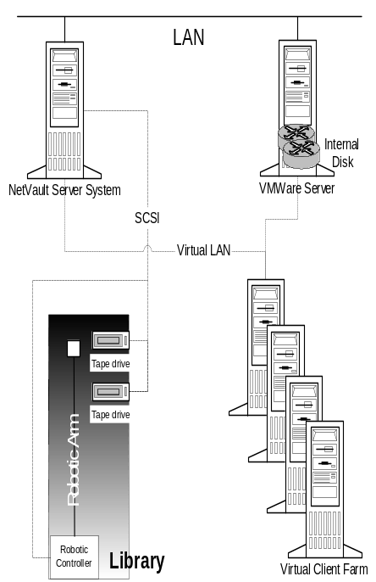 | B  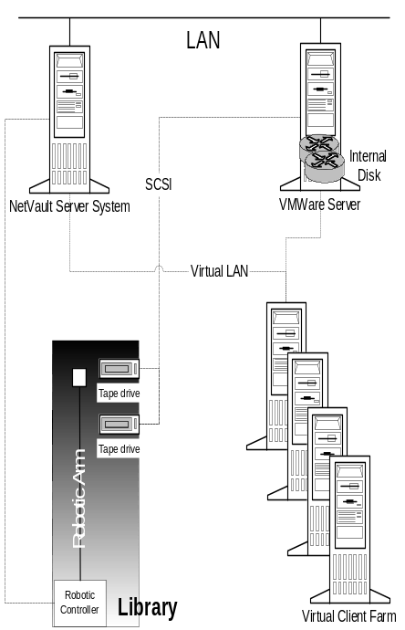 | C  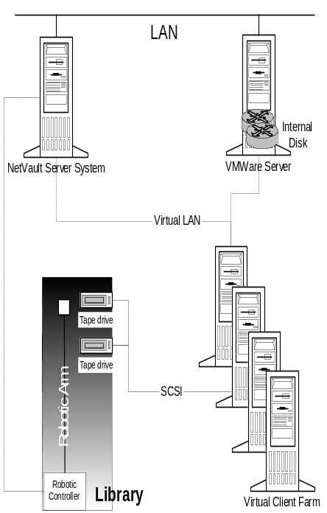
D
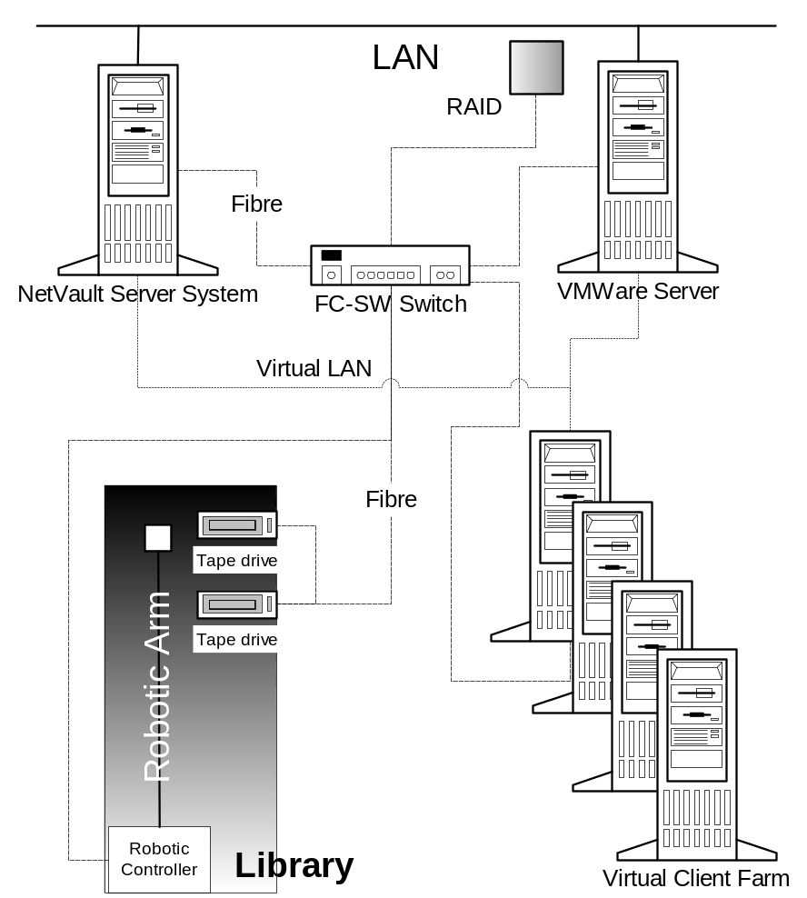

Figure 1.VMWare Validation Topology

Roles and Configurations
The configurations targeted for test and validation include various operating systems and binaries running as guest operating environments within Virtual Machines hosted by the ESX server. These environments will be targeted for backup and restore operations via two main Backup Server Domains. These environments are listed in table 4 and should be reviewed for approval.

Table 5.Environments Under Test - Roles and Configurations
System | Operating System | Role | Configuration
A | Windows 2003 SP1 | Primary Backup Server  Domain A  (Will be used for this testing) | 1 CPU: 1.5 Ghz  MEM: 512MB  Storage: 50GB Disk Space  NetWork: 1 10/100BT  1 SCSI / Fibre HBA  1 Dual Drive Library
B | RHEL V4 U1 | Secondary Backup Server  Domain B  (Optional) | 1 CPU: 1.5 Ghz  MEM: 512MB  Storage: 50GB Disk Space  NetWork: 1 10/100BT  1 SCSI / Fibre HBA  1 Dual Drive Library
C | Windows 2003 SP1 | Tertiary Backup Server  Domain C  (Optional) | 1 CPU: 1.5 Ghz  MEM: 512MB  Storage: 50GB Disk Space  NetWork: 1 10/100BT  1 SCSI / Fibre HBA  1 Dual Drive Library
D | ESX Server  Version 3.0 | Primary VMWare Server | 2 CPU: 1.5 Ghz  MEM: 4GB*  Storage: 500GB Disk Space  NetWork: 1 10/100BT  1 SCSI / Fibre HBA  1 RAID Subsystem
E | Windows 2003 SP1 | Virtual Client 1  Core Testing | 24MB+192MB+(1.06*1*(256MB+54MB))
F | RHELV4U3 | Virtual Client 2  Core Testing | 24MB+192MB+(1.06*1*(256MB+54MB))
*Total System Memory will depend on minimum guest operating system requirements (highlighted in bold within table 5) and a formula which outlines ESX server / Console and virtual system requirements. This formula is as follows:
- 24MB_192MB+(1.06*N*(M+54MB)) where N=number of virtual machines and M=total target memory for each virtual machine.

Test Requirements
This section states testing scope for VMWare ESX 3.0 backup and restoration.
The listing below identifies those items (use cases, functional requirements, non-functional requirements) that have been identified as targets for testing. This list represents what will be tested:

Configurations
- XXXXXXX Server running on Windows 2003 SP1 with XXXXXXX 7.4.2 and 7.1.2
- XXXXXXX Client running on ESX Server 3.0 with XXXXXXX 7.4.2 and 7.1.2
Operations
- Filesystem Backup to Primary Servers via locally attached device(s). Data from Virtual Machines (Refer to table 2 for details) and ESX Service Console.
- Filesystem Restore from Primary via locally attached device(s). Data to Virtual Machines (Refer to table 2 for details) and ESX Service Console.
- Filesystem Backup² to Primary and Secondary Servers via Smart Client with remotely attached device(s). Data from Virtual Machines (Refer to table 2 for details) and ESX Service Console.
- Filesystem Restore² from Primary and Secondary Servers via Smart Client with remotely attached device(s). Data to Virtual Machines (Refer to table 2 for details) and ESX Service Console.
- VMFS – Virtual Machine File direct Backup and Recovery.
Major Components to be tested for backup and recovery
- Virtual disks
- Virtual machine configuration files
- The configuration of the ESX Server itself

New features shall be tested
This is strictly a compatibility/validation testing with new version of VMWare ESX server 3.0 for a GA XXXXXXX server and client products. So no new features validation required for this project.

Faults Fixed
This is strictly a compatibility/validation testing with new version of VMWare ESX server 3.0 for a GA XXXXXXX server and client products. So no faults validation required for this project.

Test Strategy
The Test Strategy presents the recommended testing approaches. The previous section on Work Products Under Test and Test Requirements described what should be tested; this describes how it shall be tested.
Phase 1: The primary strategy will be to determine if there are any issues with simple backup and restore operations when conducting said operations on ESX Server 3.0 service console server which also has two guest operating environments hosted by VMWare Virtual Machines. The primary tool for this will be the VMWare ESX Test Suite.doc, the file system plugin test script (if applicable), test data generation, and test data validation tools. In addition there may be a need to run subsequent test cases based on findings resulting from those efforts.

Test Script Execution
Test Suite Name | Version
Test Suite.doc | 1.1

- Full Test: All of the test cases in the related test scripts and common plugin test script must be run.
- Reduced Test (Port Test): All of the test cases marked as “Port Test” in related testscripts must be run. (Note: XXXXXXX may need to ‘specify’ or define reduced port test sections from the current test script)
- QA cannot skip any test cases in the test scripts without approval from QA lead engineer.

Regression Testing
- New fault found during regression testing shall be retested again, once XXXXXXX provides new binary that addresses the issues. However, it is the right of XXXXXXX to determine whether the fixes should be included in the release or not.
- When receiving new binary to address bad fixed FMSes, only FMSes retested not fixed and not started in previous binaries shall be tested in this new binary.
- Testing shall be completed when all tests in the test plan (Testscript execution and regression testing) pass on the designated platforms and documentation is uploaded to DMS.

Testing Types

Phase | Unit Test | Integration Test | Testing Type
Phase 1 | N/A | N/A | System Testing (Test script Execution)
Phase 2 | N/A | N/A | Regression Testing
The following table outlines the test iterations to be executed per platform targeted for validation (outlined in table 2) as follows:
Table 6. Test Iterations
Iteration | Unit Test | Integration Test | System Test/Acceptance Test
<Iteration 1> | N/A | N/A | VMWare – Full and Reduced Outstanding FMS Testing

Testing Criteria

Test Readiness Criteria
- Test plans are reviewed, updated and approved.
- Testcases for faults fixed/new features in related ERN must be added to testscript.
- All related hardware devices to setup test environment are ready for testing.
- XXXXXXX Core and xxxx binaries are available.
- XXXXXXX build available, test environment / equipment available and configured, tests reviewed and a testing order determined.

Test Stop Criteria
- Successful completion of all specified tests (see test success criteria)
- Critical/High faults found during testing are not fixed.
- When no targeted functionality is testable for whatever reason.
- Note a showstopper in one area of functionality should not be allowed to hold up the continuation of testing in other areas of the build.
- All Test Deliverables have been produced and uploaded.

Test Success Criteria
- No Severity 1 level issues. As defined in the XXXXXXX Customer Support Handbook, Severity 1 issues are defined as: “Customer cannot recover data critical to its business, and there is no workaround available.”
- For test specifications being run pass criteria is stated in those documents.
- No compatibility issues with ESX Server 3.0. XXXXXXX should support ESX Server 3.0 constantly as it does with previous VMWare ESX Server versions being supported (ESX 2.5.x…)
- Finish all test scripts and all are marked as Passed for designated platforms in the scope.
- Finished all other test cases in the scope and the result is reviewed/accepted/approved by QA Lead Engineer.

Regression Test Criteria
- Regression testing coverage shall be determined by consultation with development and the QA lead engineer.
- The trigger for regression testing shall be changed which put critical or high importance functionality at any real risk

Engineering Documentation System Criteria
- Any limitations or restrictions of the plugin shall be documented in the Engineering Release Notes (ERN)
- Based on SQA process, Application Note or ERN for this project should be created and completed by test team if needed.

Tools
The following tools shall be employed for this project:
Tools Name | Tool | Vendor/In-house | Version | Location
Testing Process | SQA Process.doc | In house | 2.2 | xxxxxx
Defect Tracking | Jira system | In house | 3.0 | xxxxxx
Project Management | Project Schedule.mpp | Microsoft | 1.0 | xxxxxx
DBMS tools | xxxx specific | N/A | N/A | xxxxxx
Test Data | Test Data Generator | In house | TBA | xxxxxx
VMWare Account Information | xxxxxxx | In house | N/A | xxxxx
VMWare Technical Information | xxxxxxx | N/A | N/A | xxxxx

Resources
This section presents the recommended resources for the testing of VMWare ESX 3.0 project, their main responsibilities, and their knowledge or skill set.
This table shows the staffing assumptions for the project. More QA resources shall/can be staffed in the future based on workload and deadline of the release.

Staffing
Worker | Minimum Resources Recommended  (Number of workers allocated full-time) | Specific Responsibilities/Comments
Test Manager | xxxx | - Provides management oversight  - Acquire appropriate resources  - Management reporting
QA Lead Engineer | xxxxx | - Generate test plan  - Identifies, prioritises, and implements test cases  - Provide technical direction  - Evaluate effectiveness of test effort  - Participate partly in testing activities
QA Engineer | XXXXXXX x 2 | - Update testscript with testcases for new features  - Execute tests  - Log results  - Recover from errors  - Document defects  - Report progress and test run issues

Hardware/Devices & Software

Hardware and Devices

On x86 Based System
- 1 ESX Server: Use test cells offshore.
- 1 XXXXXXX Backup Server: Use test cells offshore
- Tape Device (use VTL or physical device)

On x86-64 Based System
- 1 ESX Server: Use remote test cells from SD Lab.
- 1 XXXXXXX Backup Server: Use remote test cells from SD Lab.
- Real Tape Device

The following table sets forth the system resources for the testing project.

System Resources
Resource | Name / Type
Network/Subnet | Required
Server XXXXXXX platforms | Required – Type dependant on build under test. - See Section 2 above.
VMWare ESX Server platform | Required – Type dependant on appliance under test. - See Section 2 above.
Client XXXXXXX platforms | Required – Type dependant on build under test. - See Section 2 above.
Tape Library or Equivalent | Required – Must be compatible with ESX Server Software
RAID | Required – Must be compatible with ESX Server Software

Software
XXXXXXX will download ESX Server 3.0 ISO from VMWare web site.
xxxxxxxxxxxxxxxxxxxxx

Machine Setup Model
This section states the machine setup model for the execution of this project.
- 01 ESX Server 3.0 for each testing (71.2 and 7.4.x)
- 01 xxxxx for each testing (7.1.2 and 7.4.x)
- If possible, use real tape drive or tape drive library. Otherwise, use VTL.

Communications Channels
All project communications/issues/problems are handling following the channels in the chart above:
Contact information:
xxxxxxxxxxxxxxxxxxxxxxxxxxxx

Estimation
The below table presents the estimation for this project. The project cycle is broken down into Plan / Prepare / Execute / Closure phase with appropriate high-level tasks. Please refer to project schedule (MPP) file to get more detail information about tasks, progress, and milestones with appropriate start dates, end date, assigned resources

Phase | Task | Effort (man-day)
Plan | Gather and review requirements, specifications | 1
Plan | Create test plan | 1
Plan | Review Test plan | 1
Plan | Total Plan Effort: | 3
Prepare | Add/Modify testcases | 0
Prepare | Review/Approve new testscript (XXXXXXX and XXXXXXX) | 0
Prepare | Total Prepare Effort: | 0
Execute | Installation and ENV configuration (for each x86/x86-64 based system) | 3
Execute | Full Test Scenario
Execute | Test_Suite_v10_OCT_2005 | 4
Execute | Reduced Test Scenario
Execute | Test_Suite_v10_OCT_2005 | 3
Execute | Total Execution Effort for 1 Full Test and 1 Reduced Test: | 10
Execute | Total Execution Effort on 2 systems (2 Full Test, 2 Reduced Test): | 20
Closure | Review/approve test result | 0.5
Closure | Create test summary report | 0.5
Closure | Total Closure Effort: | 1
Total Effort (man-days): |  | 24
Total Duration (2 engineers) - Working Days: |  | 12
Tentative Schedule (Execution & Closure only) - Calendar Days: |  | July 13– August 1

Deliverables
This is the list of deliverable items necessary for this project. It includes deliverable items from XXXXXXX to XXXXXXX and from XXXXXXX to XXXXXXX. For all test specs run:
A copy of the specification that has been run, renamed to reflect the test build under test.

# | Deliverable Name | From | Status/Action | Comment
1 | Test Plan | Tham Nguyen | XXXXXXX/ Reviewed | This document will be updated during the course of the project, for any changes in scope / requirement.
2 | Test Script | XXXXXXX | XXXXXXX/Reviewed/Updated
3 | Binaries for Testing | XXXXXXX | GA/MA | Binaries for XXXXXXX and other plugins if applicable
4 | Test Result | XXXXXXX | N/A | Completed testscripts, ERN
5 | Test Summary Report, Fault Report | XXXXXXX | N/A
8 | Project Plan | Vu Pham  Don Le Brandon Pham | N/A | To monitor and report tasks

Test Artifacts
- Test Plan (this document)
- Related test scripts
- Engineering Release Notes of related binaries.
- Test Suites
- Jira Audit
- Specific data sets created and used in the testing.
- Application Notes
- Training Materials

Test Logs
- Completing testscripts document
- Fault Report of the project (FR)
- Test Summary Report of the project (TSR)
- Completing worksheet of fixed faults new features (ERN)

Defect Reports
- Defects are to be recorded in fault records raised or resubmitted in the Jira system. Any fault that is to be tested shall be included in this test plan, Test Report and/or Engineering Release Notes (ERN) of related BMS.
- Defects are included also in Test Summary Report in Closure phase.
- Please remember to refer to the software quality assurance (SQA) process document found at the following location in DMS, for process guidelines: Documents/Test and Quality Assurance/Process, Procedures and Guides/SQA Process Document/SQA Process.doc

